Student Name: Mohammad Lutfi Buhamad | Report No: 4
Student ID: 2240005142 | Date: 9/28/2025

- Task#1: Write a program that asks the user to enter an integer and then displays the number of 1's in the binary representation of that integer. For example, if the user enters 9, then the program should display 2.
Solution: 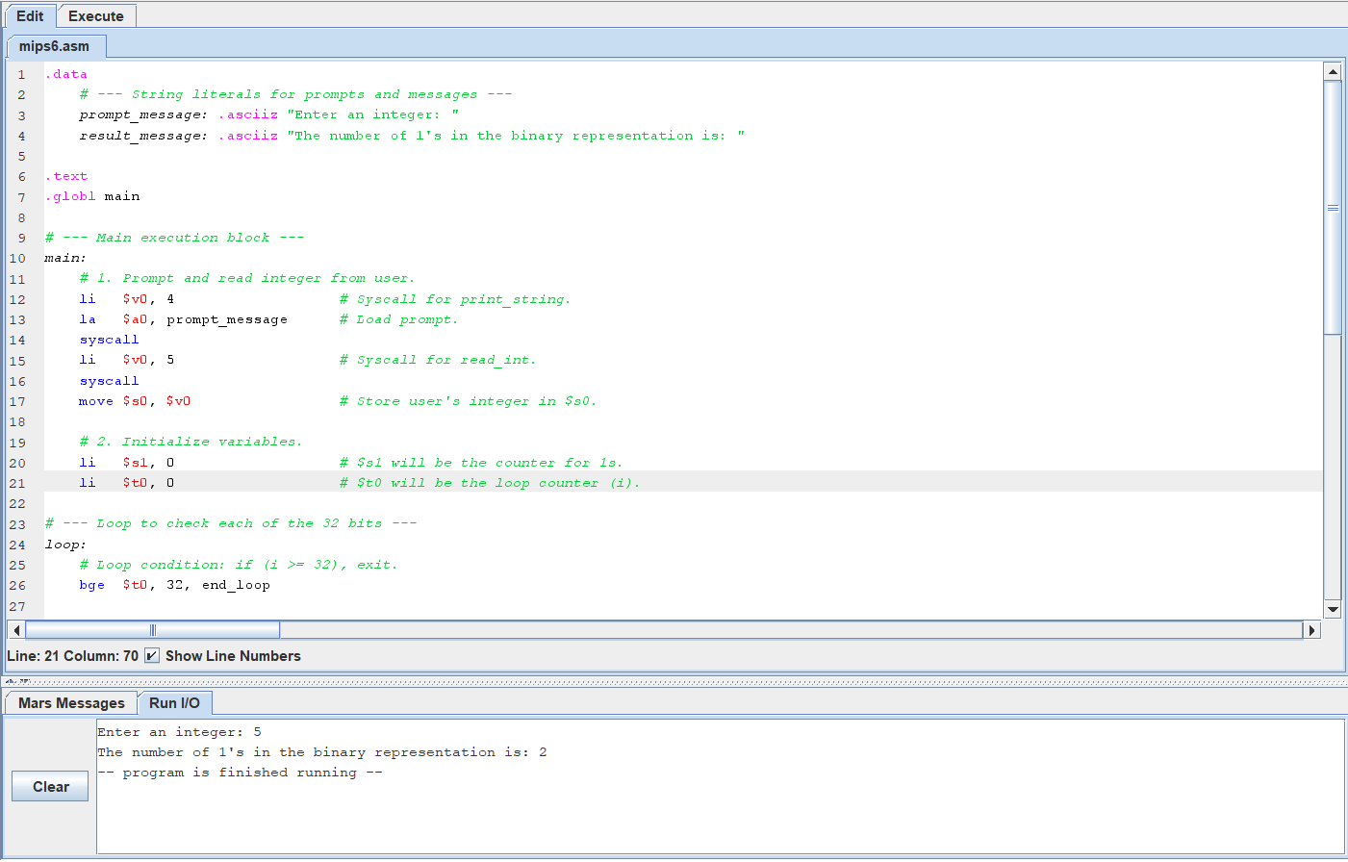
Task#2: Write a program that asks the user to enter two integers: n1 and n2 and prints the sum of all numbers from n1 to n2. For example, if the user enters n1=3 and n2=7, then the program should display the sum as 25.
Solution: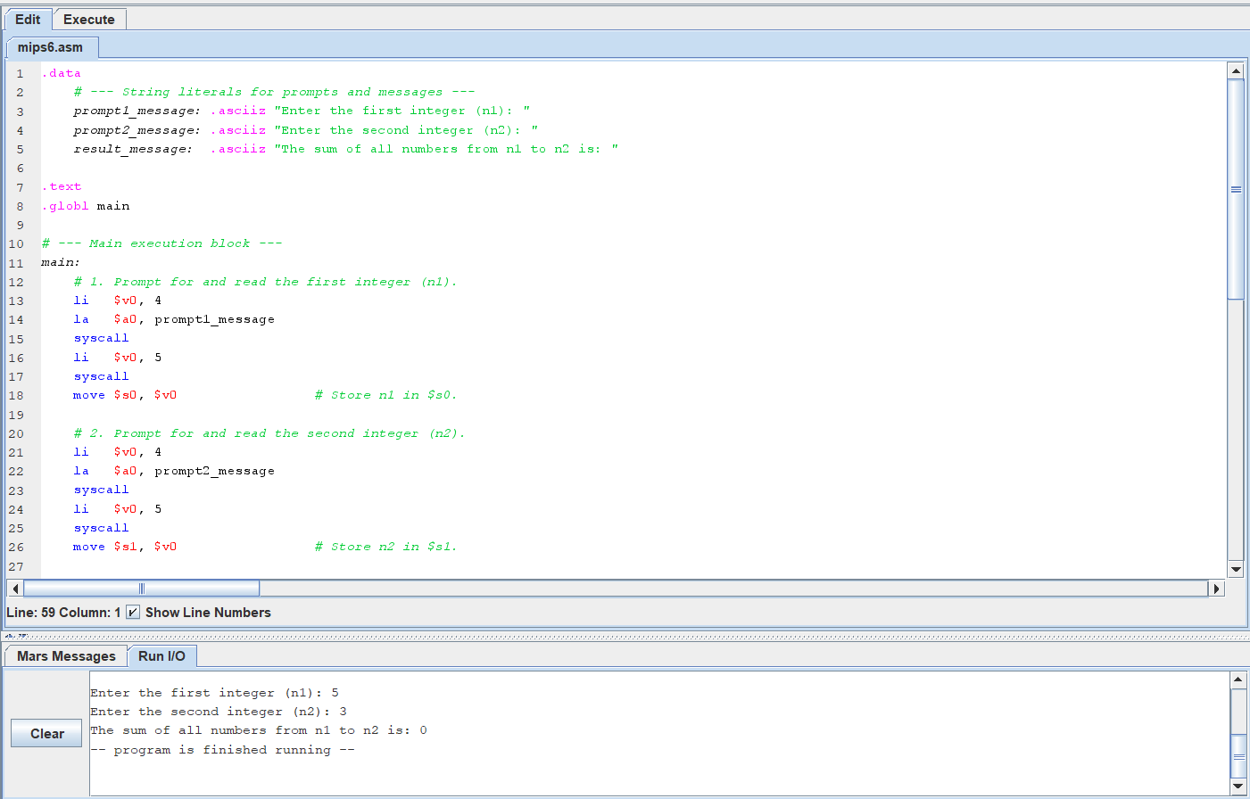
- Task#3: Write a program that asks the user to enter an integer and then display the hexadecimal representation of that integer.
Solution: